24th January 2013www.dstp.cheshire.sch.uk

**Text message service: 01829 470000**

**Text message service: 01829 470000**

**Text message service: 01829 470000**

**Text message service: 01829 470000**

**www.dstp.cheshire.sch.uk**



**‘Be the best you can be.’**

September 2020

**CLASS TWO NEWSLETTER – Autumn Term**

**Please email me or phone the office and request a telephone call if you have any concerns or questions.**

**Email: c.entwistle@dstp.cheshire.sch.uk**

**Mon- Thurs - Mrs Entwistle**

**Friday- Mrs Kinsey/ Mark Phillips (PE)**

**Mrs Garnham is in school Tuesday- Fri**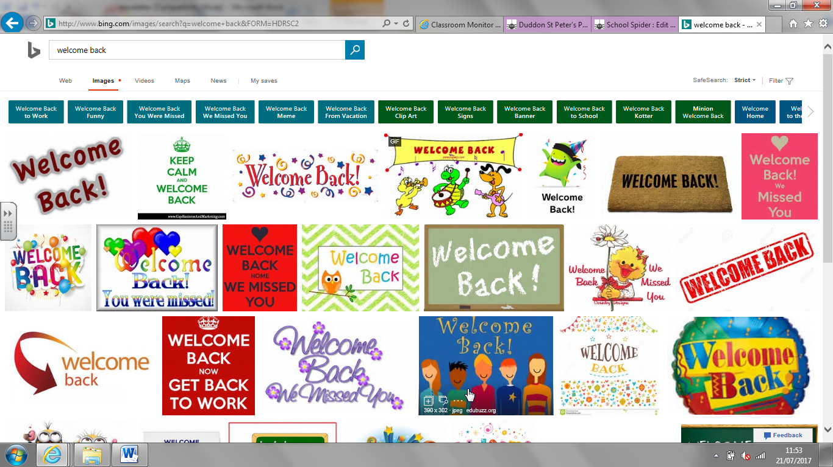

**Topics for the Autumn Term:**

**Topic**: The Stone Age to the Iron Age  
**Science**: Rocks and Fossils

**Art:** Stone Age art

**RE:** Religions / festivals

**Maths-** Place Value and Multiplication

**Literacy text-** The Wild Way Home

**Welcome back, we hope you’ve all had a lovely summer! We are really looking forward to being back together.**

**As we adapt to our new routines, can we kindly ask that you line up on the dots by the cloakroom in the morning. A maximum of five children will be let in at a time. Children can be collected from their classroom as normal at 3.30pm.**

**Claire Entwistle & Mel Pickering**

Children in Class Two will have PE on a Monday and Friday morning. Please can they come to school in their PE kits.

Please remember to name all clothing and ensure that your child has a coat each day. Children also need tissues and a water bottle.

**Now that the children are in the juniors, a few of them have asked if they can bring in their own pencil case. If they wish to do this, please could they bring a small pencil case containing the following: Pencil, rubber, sharpener, coloured pencils, red biro and a green biro. No tape, staplers, or compasses please. All materials are provided within school and children have their own pots on their tables, so parents should not feel any pressure to rush out and buy new items.**

**Reading assessments are taking place and children will be issued with their new reading book in the next few days.**

Homework will be given out at the end of next week. We hand homework outat the beginning of each term and ask that children complete a piece each week. This can be Literacy, Numeracy based. Children will be able to select their own task; we have found that they respond well to this approach. In addition, children are asked to read each night and complete weekly spellings.

**The Council’s draft budget proposals for 2013/14 have now been published on the website, along with an online feedback for via the following link: www.cheshirewestandchester.gov.ukbudgetconsultation.   
The closing date for feedback is 28 January.**

**www.dstp.cheshire.sch.uk**

**Please see our school webpage to give you an overview of our plans and tell you what we have been up to. We will add art work, displays and activities over the coming weeks.**

**www.dstp.cheshire.sch.uk**

**Spellings:**

**Due to the extended absence from school, we are not sending spellings out straight away. Children being assessed on spellings each week in class. We will send individual lists out over the next couple of weeks. Spellings tests will be on Thursdays once our normal routine starts.**

**Text messaging service: 01829 470000**

**The Council’s draft budget proposals for 2013/14 have now been published on the website, along with an online feedback for via the following link: www.cheshirewestandchester.gov.ukbudgetconsultation.   
The closing date for feedback is 28 January.**