Local Study – Homework
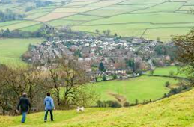
- Make salt crystals
- Design a brochure for Cheshire – Make your brochure colourful and exciting. Add pictures/photos of interesting places. Use vocabulary that is interesting to the reader and will encourage them to visit the county.
- Create a model of an important landmark in Cheshire – Jodrell Bank, Chester Cathedral, Tatton Park, Anderton Boat Lift etc.
- Research what Cheshire is famous for – Cheese, Salt, Silk. Present your findings in a fact file.
- Explore your local area – Visit a park, village, town, a place of interest etc. Take photos and make notes
of the wildlife, buildings, plants.
Present your exploration to the class or design a map of the place you visited.

Remember these are just ideas. Feel free to come up with your own creative ideas

